Saunil Dobariya
Sylvia Guan
Elizabeth Lee
Meggie Dinh
WWII DBQ
During the years leading up to WWII, America was taking a stance and making a name for itself internationally. The area in which most people note as greatly disputed is politics during this time period. Many people regard this time as either a period of great change in politics or one in which politics did not change at all in the United States. To what extent did United States politics change between 1933 and 1945 in the areas of domestic policy, foreign policy, and government action?

Document A

Document B

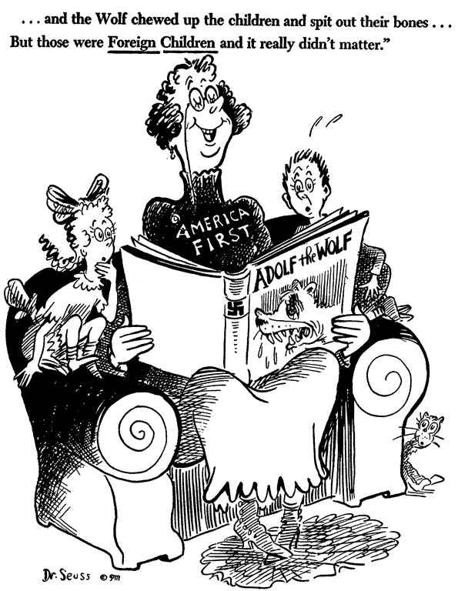

Document C
U.S. Declaration of War on Japan
Resolved by the Senate and House of Representatives of the United States of American in Congress assembled, that the states of war between the United States and the Imperial Government of Japan which has thus been thrust upon the United States is hereby formally declared; and the President is hereby authorized and directed to employ the entire naval and military forces of the United States and the resources of the Government to carry on war against the Imperial Government of Japan; and, to bring the conflict to a successful termination, all of the resources of the country are hereby pledged by the Congress of the United States.

Document D
Joint Resolution of the U.S. Congress Reaffirming the Principles of the Monroe Doctrine
April 10, 1941
JOINT RESOLUTION

Whereas our traditional policy has been to consider any attempt on the part of non-American powers to extend their system to any portion of this hemisphere as dangerous to the peace and safety not only of this country but of the other American republics; and […]

Resolved by the Senate and House of Representatives of the United States of Aemrica in Congress assembled, (1) That the United States would not recognize any transfer, and would not acquiesce in any attempt to transfer, any geographic region of this hemisphere from one non-American power to another non-American power; and

(2) That if such transfer or attempt to transfer should appear likely, the United States shall, in addition to other measures, immediately consult with the other American republics to determine upon the steps which should be taken to safeguard their common interests.

Document E

Roosevelt Campaign Speech at Boston, Massachusetts Oct. 30, 1940

And while I am talking to you mothers and fathers, I give you one more assurance.

I have said this before, but I shall say it again and again and again:

Your boys are not going to be sent into an foreign wars.

They are going into training to form a force so strong that, by its very existence, it will keep the threat of war far away from our shores.

The purpose of our defense is defense.

The Republican campaign orators who moan and groan (laughter) about our Army and Navy are even more mournful about our strength in the air. But only last year, 1939, the Republicans in, the Congress were voting in favor of reducing appropriations for the Army Air Corps.

What kind of political shenanigans are these?

Can such people be trusted with national defense?

I stress particularly what every Army and Navy flier tells us-that what counts most in sustained air power is the productive capacity of our airplane and engine factories. That ought to be almost a first-grade lesson.

We are determined to attain a production capacity of 50,000 planes a year in the United States. And day by day we are working and making rapid progress toward that goal.

Document F

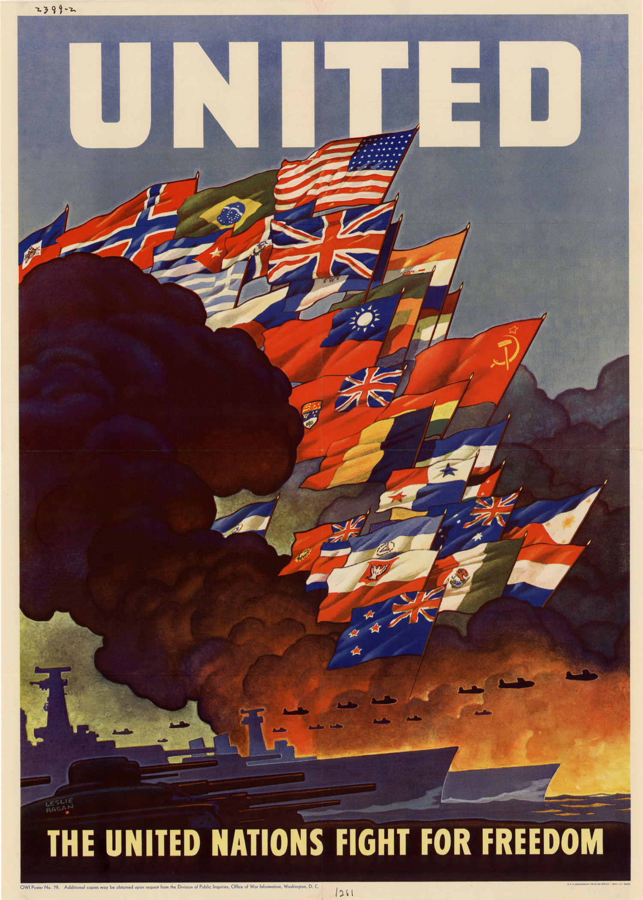

Document G
Neutrality Act of November 4, 1939
JOINT RESOLUTION To preserve the neutrality and the peace of the United States and to secure the safety of its citizens and their interests. Whereas the United States, desiring to preserve its neutrality in wars between foreign states and desiring also to avoid involvement therein, voluntarily imposes upon its nationals by domestic legislation the restrictions set out in this joint resolution; and Whereas by so doing the United States waives none of its own rights or privileges, or those of any of its nationals, under international law, and expressly reserves all the rights and privileges to which it and its nationals are entitled under the law of nations; and
Whereas the United States hereby expressly reserves the right to repeal, change or modify this joint resolution or any other domestic legislation in the interests of the peace, security or welfare of the United States and its people: Therefore be it Resolved by the Senate and House of Representatives of the United States of America in Congress assembled,
PROCLAMATION OF A STATE OF WAR BETWEEN FOREIGN STATES SECTION 1. (a) That whenever the President, or the Congress by concurrent resolution, shall find that there exists a state of war between foreign states, and that it is necessary to promote the security or preserve the peace of the United States or to protect the live of citizens of the United States, the President shall issue a proclamation naming the states involved; and he shall, from time to time by proclamation, name other states as and when they may become involved in the war.
(b) Whenever the state of war which shall have caused the President to issue any proclamation under the authority of this section shall have ceased to exist with respect to any state named in such proclamation, he shall revoke such proclamation with respect to such state.

Document H

Document I
President Franklin D. Roosevelt’s Message to Congress
- To keep the cost of living from spiraling upward, we mus tax heavily, and in that process keep personal and corporate profits at a reasonable rate, the word “reasonable” being defined at a low level.
- To keep the cost of living from spiraling upward, we must fix cielings on the prices which consumers, retailers, wholesalers and manufacturers pay for the things they buy; and ceilings on rents for dwellings in all areas affected by war industries.
- To keep the cost of living from spiraling upward, we must stabilize the remuneration received by individuals for their work.
- To keep the cost of living from spiraling upward, we must stabilize the prices received by growers for the products of their lands.
- To keep the cost of living from spiraling upward, we must encourage all citizens to contribute to the cost of winning this war by purchasing War Bonds with their earnings instead of using those earnings to buy articles which are not essential.
- To keep the cost of living from spiraling upward, we must ration all essential commodities of which there is a scarcity, so that they may be distributed fairly among consumers and not merely in accordance with financial ability to pay high prices for them.
- To keep the cost of living from spiraling upward, we must discourage credit and installment buying, and encourage the paying off of debts, mortgages, and other obligations; for this promotes savings, retards excessive buying and adds to the amount available to the creditors of War Bonds.

Document J

Selective Training and Service Act of 1940
Sec. 2. Except as otherwise provided in this Act, it shall be the duty of every male citizen of the United States, and of every male alien residing in the United States, who, on the day or days fixed for the first or any subsequent registration, is between the ages of twenty-one and thirty-six, to present himself for and submit to registration at such time or times and place or places, and in such manner and in such age group or groups, as shall be determined by rules and regulations prescribed hereunder.
Sec. 5. (a) Commissioned officers, warrant officers, pay clerks, and enlisted men of the Regular Army, the Navy, the Marine Corps, the Coast Guard, the Coast and Geodetic Survey, the Public Health Service, the federally recognized active National Guard, the Officers' Reserve Corps, the Regular Army Reserve, the Enlisted Reserve Corps, the Naval Reserve, and the Marine Corps Reserve; cadets, United States Military Academy; midshipmen, United States Naval Academy; cadets, United States Coast Guard Academy; men who have been accepted for admittance (commencing with the academic year next succeeding such acceptance) to the United States Military Academy as cadets, to the United States Naval Academy as midshipmen, or to the United States Coast Guard Academy as cadets, but only during the continuance of such acceptance; cadets of the advanced course, senior division, Reserve Officers' Training Corps or Naval Reserve Officers' Training Corps; and diplomatic representatives, technical attaches of foreign embassies and legations, consuls general, consuls, vice consuls, and consular agents of foreign countries, residing in the United States, who are not citizens of the United States, and who have not declared their intention to become citizens of the United States, shall not be required to be registered under section 2 and shall be relieved from liability for training and service under section 3 (b).

Facts and Inferences
Document A
Facts:
- The draft was the first peacetime draft during American history
- It was heavily favored by many
- At this time, the dream of being isolated was destroyed in America
Inferences:
- This change in how the American people felt about the draft showed domestic change
- The draft itself was also a change in how America prepared for war

Document B
Facts:
- Americans were split on the issue of isolationism.
- Many people died during the war but American wanted to stay isolated.
- They seemed to not care for the results of the war in Europe
Inferences:
- These actions led to ill feelings towards America
- The image of Isolationism did not change in American politics

Document C
Facts:
- Japan provoked US to start war
- US formally declare war on Japan
- President allowed to use US navy and military to fight against Japan
Inference
- US ended their isolation policy after many years
- US angered at Japan’s attack on Pearl Harbor

Document D
Facts:
- US would work with Latin America to help protect them
- Monroe Doctrine would apply to the other countries in the Americas
- US will not recognize any Latin American countries taken by force
Inference
- US feared that Axis powers would try to take Allies’ colonies in America
- US was afraid that Germany’s power growing too strong

Document E
Facts
- US began working together with the other countries
- US were fighting against communism
- US entered WW2
Inference
- US ended from their isolation policy
- US join sides with Allies to fight against Axis powers

Document F
Facts:
-FDR felt strongly that he would not put American soldiers in WWII.
-He believed in defense only, rather than fighting.
-FDR emphasized the need for factories to churn out war materials.
Inferences:
-There were many who feared America going to war and they were those who advocated going to war.
-He reinforces the isolationism with the idea of “defense” only and nonintervention.

Docment G
Facts:
- The US was not going to go get itself in the War
- The United States was set on staying isolated
- Isolationism was rampant during this time
Inferences:
- The American People agreed to stay out of the war
- The Neutrality Act will ironically lead to the joing of America to WW2

Document H
Facts:
- Roosevelt was breaking the two term tradition.
- Although Willke was a republican candidate, they did not want Roosevelt, a democrat, to break the sacred two term tradition.
- Uncle Sam disagreed with the three term
Inference:
- People thought that Roosevelt was going to be like a dictator
- The democrats were split on the decision, two sides for and against a third term

Document I
Facts:
- They want to keep living cost low and prevent it from going higher
- War Bonds were made available to purchase and help the military
- The seven principle points were made to keep the living cost down while having it be reasonable for the citizens
Inferences:
- People were buying unnecessary things, such as articles
- The government is doing what they always do (raise tax) to regulate the economy

Document J
Facts
- The United States issued their first peacetime draft
- The president had more control over the military during this time
- Many men were required to join
Inferences
- The U.S. was changing to fit its needs
- The government was taking more control over civilian life

Points of Outside of Information

- Tydings-McDuffie Act
- Reciprocal-Trade Agreement Act
- Seventh Pan-American Conference
- London Economic Conference
- Quarantine Speech
- Havana Conference
- America First Committee
- Lend-Lease Bill
- Cash-and-carry
- Attack on Pearl Harbor
- Atlantic Charter
- Good Neighbor Policy
- Wendell Willkie
- Mandatory conscription
- Seventh Pan-American Conference
- Monroe Doctrine
- Fair Employment Practices Commission
- "Negro March on Washington"
- A. Philip Randolph
- War Production Board
- Smith-Connally Anti-Strike Act
- Wagner Act
- New Deal
- Japanese Internment
- Korematsu v. U.S.
- Office of Price Administration
- Tehran Conference
- Braceros

